**Image Classification Using Convolutional Neural Network**

**PROJECT SYNOPSIS**

**Machine Intelligence**

**BACHELOR OF TECHNOLOGY- V Sem CSE**

## **Department of Computer Science & Engineering**

SUBMITTED BY

**Batch No:-**

Student name 1: Gurukiran SRN: PES1UG20CS156

Student name 2: Gautam R A SRN: PES1UG20CS151

Student name 3: Jayasimha S SRN: PES1UG20CS177

## **PES UNIVERSITY**

## **(Established under Karnataka Act No. 16 of 2013)**

## **100 Feet Ring Road, BSK III Stage, Bengaluru-560085**

**Abstract and Scope**

Image classification is **the process of categorizing and labeling groups of pixels or vectors within an image based on specific rules.**

Classification between objects is a complex and tedious task. Therefore image classification has been an important task within the field of computer vision. Image classification refers to the labelling of images into one of a number of predefined classes. There are potentially n number of classes in which a given image can be classified. Manually checking and classifying images could be a tedious task especially when they are massive in number and therefore it will be very useful if we could automate this entire process using the deep learning algorithm of Convolutional Neural Networks.

* Tensor flow : It is an open source library developed by Google primarily for deep learning applications. Tensorflow has a better data visualization than any other library. This makes it working on neural networks easier.
* CNN has three layers such as Convolutional, Pooling and Fully Connected layer.
* Convolutional Layers : It is a core building block of CNN where majority computation occurs. It will convert image to matrix of pixels.
* Pooling Layer : It is used to reduce the size of images, so that number of computation in network are reduced.
* Fully Connected Layer : These layers are an essential component of CNN, which have been proven very successful in recognizing and classifying images for computer version.

It is used in many areas such as Medical Imaging, Traffic Control System, Maps, Object Identification in Satellite images .

**Feasibility Study**:

Image Classification will help in the field of Agriculture, Medical, Satellite, Traffic Signals.

Deep learning algorithms have accounted for the rapid acceleration of research in artificial intelligence in medical image analysis, interpretation, and segmentation with many potential applications across various sub disciplines in medicine. However, only limited number of research which investigates these application scenarios, are deployed into the clinical sector for the evaluation of the real requirement and the practical challenges of the model deployment. In this research, a deep convolutional neural network (CNN) based classification network and Faster RCNN based localization network were developed for brain tumor MR image classification and tumor localization. A typical edge detection algorithm called Prewitt was used for tumor segmentation task, based on the output of the tumor localization.

Protecting crops in organic farming is not an easy task. This depends on a thorough knowledge of the crop being grown and possible pests, pathogens and weeds. A special deep learning model has been developed based on a special architectural convolution network to detect plant diseases through images of healthy or diseased plant leaves. The system can be upgraded to a real-time video entry system that allows unattended plant care. Another aspect that can be added to certain systems is an intelligent system that cures identified ailments. Studies show that managing plant diseases can help increase yields by about 50%.

We use a deep learning architecture, convolutional neural network (CNN) which is currently the state-of-the art for image processing method. We only do minimal image preprocessing steps on the small size image, where the conventional methods require a high quality, handcrafted features need to do manual calculation. The CNN model is trained to do binary classification about road traffic condition using 1000 CCTV monitoring image feeds with balance distribution. The result shows that a CNN with simple, basic architecture that trained on small grayscale images has an average classification accuracy of 89.50%.

**Design Approach/ Methodology/ Planning of work**

CNNs are used for a variety of tasks in computer vision , image classification and object detection , TensorFlow framework enables to create highly flexible CNN architectures for computer vision tasks.

The CNN classifier is first trained on a set of known data pertaining to different class of objects , using multiple layers in the neural network  we have greatly reduced the dimensions of the image, we can use the tightly meshed layers. Here, the individual sub-images are linked again in order to recognize the connections and to carry out the classification

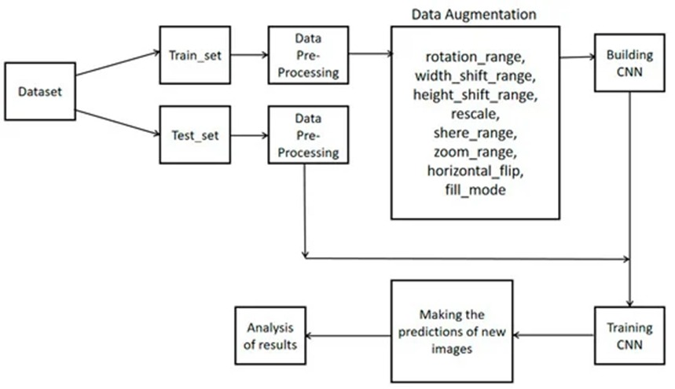

### References

Specify the description of the conference/ Journal paper you have studied for the project.

1. Yushi Chen, Hanlu Jiang, Chunyang Li, Xiuping Jia, “Deep feature extraction and classification of Hyperspectral images based on Convolutional Neural Network (CNN)” IEEE Transactions on Geoscience and Remote Sensing, vol. 54, no. 10, pp. 6232-6251, 2016.
2. Convolutional Neural Networks for Image Classification and Captioning Sachin Padmanabhan Department of Computer Science, Stanford University.
3. Image Classification, Deep Learning and Convolutional Neural Networks A Comparative Study of Machine Learning Frameworks Rasmus Airola and Kristoffer Hager 2017 The author(s) and Karlstad University
4. https://www.ijser.org/researchpaper/image-classification-using-convolutional-neural-networks.pdf